EXPERIMENT-3

3.A logistics company wants to deliver goods with the minimum transportation cost.
Implement Uniform Cost Search (UCS)
Algorithm.
Find the least-cost path between source and destination.

PROGRAM CODE:
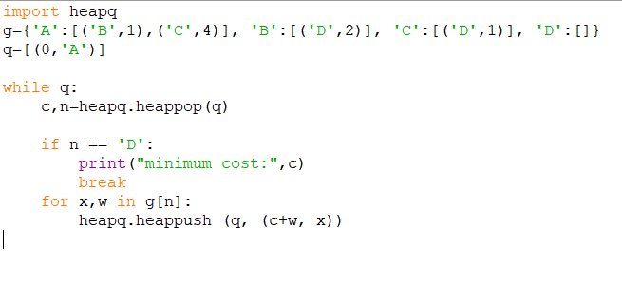

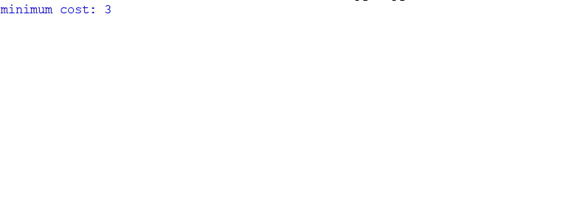
OUTPUT SCREENSHOT:

